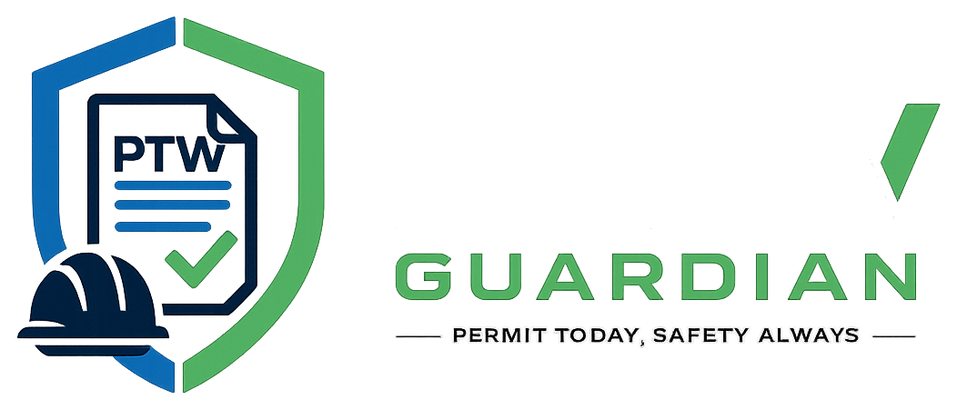
INSTALLATION + FIRST RUN
PTW V1 First-Time Setup and Run Guide
How to open the ZIP or GitHub project and run it on another Windows laptop
Purpose Give a recipient a reliable, step-by-step path from receiving the project to opening PTW Guardian at localhost:3000.

PTW V1 | Permit to Work Management System
Prepared 23 July 2026 | Version 1.0

Contents
1. What the Recipient Receives
2. Laptop Requirements
3. Option A - Start from PTW V1.zip
4. Option B - Start from GitHub
5. Configure the Environment
6. Start MySQL
7. Install Node Dependencies
8. First Application Start
9. Initial Sign-In and Accounts
10. First-Run Verification Checklist
11. Moving Existing Data to the New Laptop
12. Daily Start and Stop
13. Updating from GitHub
14. Troubleshooting
15. Recipient Handover Checklist

1. What the Recipient Receives
The project may be shared as PTW V1.zip or through the GitHub repository UptimeProDev/projek-webapp-ptw. Both contain the application source. The ZIP also includes the local dependency folder and Git history from the packaging laptop; a fresh npm install is still recommended.
Database note The active MySQL records on the original laptop are not automatically included in GitHub or a normal project ZIP. The application will create a fresh ptw database and seed development accounts. To transfer existing permits and users, also share a MySQL dump and the required uploads.

2. Laptop Requirements
Requirement | Recommended | How it is used
Operating system | Windows 10 or 11 | Matches the current XAMPP and local development workflow.
Node.js | Current LTS release | Runs server.js and installs dependencies.
MySQL | XAMPP MySQL or MySQL Server 8 | Stores all application data.
Git | Current Git for Windows | Required only for the GitHub clone/update method.
Browser | Chrome or Edge | Opens http://localhost:3000.
Disk space | At least 500 MB free | Project, dependencies, logs, uploads, and database growth.

3. Option A - Start from PTW V1.zip
- Copy PTW V1.zip to the new laptop.
- Right-click the ZIP and select Extract All.
- Choose a normal working folder such as Documents\PTW V1. Avoid running directly inside the compressed ZIP.
- Open the extracted projek-webapp-ptw folder. Confirm that server.js, package.json, package-lock.json, .env.example, and the Permit to Work Management System folder are present.
- Continue with Environment Setup and Database Setup below.

4. Option B - Start from GitHub
- Install Git for Windows.
- Open PowerShell or Command Prompt in the folder where the project should be stored.
- Run: git clone https://github.com/UptimeProDev/projek-webapp-ptw.git
- Run: cd projek-webapp-ptw
- Continue with Environment Setup and Database Setup below.
Private repository If GitHub requests access, sign in with an account that has permission to the repository.

5. Configure the Environment
- Copy .env.example and rename the copy to .env.
- Open .env in a text editor.
- Set the MySQL host, port, username, password, and database name.
- Replace SUPERADMIN_PASSWORD with a long unique password.
- Configure SMTP or SMS only when invite delivery is required.
Typical XAMPP development values:
Variable | Typical value | Meaning
PORT | 3000 | Local web server port.
DB_HOST | localhost | MySQL host.
DB_PORT | 3306 | MySQL port.
DB_USER | root | XAMPP default database user.
DB_PASSWORD | (blank by default) | MySQL password; use the actual local value.
DB_NAME | ptw | Database automatically created at first start.
SUPERADMIN_EMAIL | superadmin@example.com | Initial platform owner login email.
SUPERADMIN_PASSWORD | strong private value | Initial platform owner password.
Do not share .env The .env file can contain passwords and mail credentials. It is intentionally ignored by Git. Share .env.example and communicate secrets separately.

6. Start MySQL

6.1 Using XAMPP
- Open XAMPP Control Panel.
- Press Start beside MySQL.
- Confirm the MySQL row becomes active/green.
- If port 3306 is unavailable, resolve the conflict or update DB_PORT in .env.

6.2 Using a standalone MySQL service
Start the Windows MySQL service and ensure the .env credentials can create the ptw database and tables.

7. Install Node Dependencies
- Open PowerShell in the projek-webapp-ptw folder.
- Check Node: node --version
- Check npm: npm --version
- Run: npm install
For an exact clean installation from package-lock.json, use npm ci. If the ZIP already contains node_modules, npm install still checks and aligns dependencies.

8. First Application Start
- Confirm MySQL is running.
- From the project root, run: npm start
- Wait for: PTW backend running at http://localhost:3000
- Also confirm: Connected to MySQL database 'ptw'
- Open Chrome or Edge and visit http://localhost:3000
At startup, the server creates the ptw database if needed, creates or updates the required tables and columns, backfills organization-linked records, seeds development users, seeds the platform Superadmin, and synchronizes worker accounts.

9. Initial Sign-In Accounts
The development server seeds the following accounts when they do not already exist. These are for local demonstration and should be changed or removed before real use.
Role | Email | Development password
Admin | admin@example.com | admin12345
Requester | requester@example.com | requester12345
Supervisor | supervisor@example.com | supervisor12345
Safety Officer | safety@example.com | safety12345
Approver | approver@example.com | approver12345
Worker | worker@example.com | worker12345
Additional Worker | thyaaworker@example.com | worker12345
Platform Superadmin | Value from SUPERADMIN_EMAIL | Value from SUPERADMIN_PASSWORD
Security action Change all seeded passwords before the system is used with real people or real permit information.

10. First-Run Verification Checklist
- Login page opens at http://localhost:3000.
- Superadmin opens /superadmin.
- Organization Admin opens /organization after a tenant is created.
- Requester opens /dashboard and can create a draft.
- Admin opens /admin and sees workers and permits.
- Safety Officer opens /safety.
- Supervisor opens /supervisor.
- Worker opens /worker.
- Refresh, notifications, account, support, and logout work.
- A test draft can move through the intended workflow without cross-company visibility.

11. Moving Existing Data to the New Laptop
To reproduce the original laptop's current users, permits, workers, audit logs, and notifications, export and import MySQL in addition to sharing the project files.

11.1 Export on the original laptop
Using XAMPP shell or a terminal with mysqldump available:
mysqldump -u root -p --routines --triggers ptw > ptw-backup.sql

11.2 Import on the recipient laptop
Create/start MySQL, then run:
mysql -u root -p ptw < ptw-backup.sql
- Copy the uploads folder when attachments and profile images are required.
- Keep database dumps and uploads private because they may contain personal and safety information.

12. Daily Start and Stop

12.1 Start
- Start XAMPP MySQL.
- Open PowerShell in the project root.
- Run npm start.
- Open http://localhost:3000.

12.2 Stop
- Return to the terminal and press Ctrl+C.
- Stop MySQL in XAMPP if no other application needs it.

13. Updating from GitHub
- Protect any local .env and database backup.
- Open a terminal in projek-webapp-ptw.
- Run git status and resolve or commit local changes.
- Run git pull origin main.
- Run npm install if package files changed.
- Restart npm start. Database schema updates run automatically.

14. Troubleshooting
Problem | Likely cause | Resolution
Failed to start PTW backend | MySQL stopped or credentials incorrect | Start MySQL and compare .env with the local MySQL account.
Port 3000 already in use | Another server is running | Stop the other process or change PORT in .env.
Cannot connect to MySQL | Wrong host, port, user, or password | Test MySQL login and correct DB_* variables.
Module not found | Dependencies not installed | Run npm install in the project root.
Login fails | Wrong credentials or inactive account | Use the correct seeded account or ask an admin to reactivate access.
Organization suspended | Tenant lifecycle blocks operations | Platform Superadmin must restore the tenant.
Worker not assignable | Inactive status or permit type mismatch | Approve the profile and assign the matching work type.
Old interface remains | Browser cache | Refresh the page; script versions are cache-busted in HTML.
Attachments missing | uploads folder not transferred | Copy the original uploads folder and preserve its structure.

15. Recipient Handover Checklist
- PTW V1.zip or GitHub access provided.
- Node.js, MySQL/XAMPP, and Git requirements communicated.
- .env created locally and secrets exchanged separately.
- MySQL dump supplied if current data is required.
- uploads folder supplied if existing attachments are required.
- Superadmin and demo passwords changed.
- npm install and npm start completed successfully.
- All role pages verified at localhost:3000.

